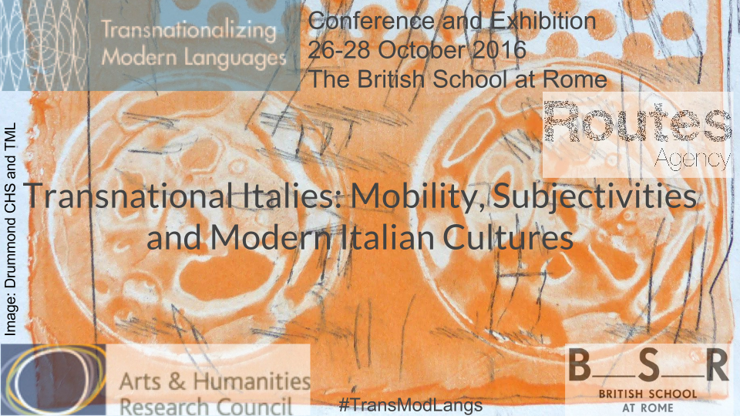

Transnational Italies: Mobility, Subjectivities and Modern Italian Cultures

The British School at Rome
Via Antonio Gramsci 61, Rome

26-28 October 2016

Conference Registration Form

Registration for non-speakers costs €20 per day payable at the registration desk on each morning of the conference.

Name:

Institution Affiliation:

Contact email:

Attendance on (please indicate):

Wednesday 26 October 2016

Thursday 27 October 2016

Friday 28 October 2016

Please return the registration form to Barbara Spadaro (b.spadaro@bristol.ac.uk) by Monday 3 October 2016

